PEC GET PROGRAM

NECOP INTERNSHIP

IC SYSTEM DESIGN VERIFICATION

VERIFICATION GUIDE OF SYSTEM VERLIOG


SUMBITTED BY
HUZAIFA SHAHBAZ

SUMBITTED TO
SHAHBAZ AHMAD

DEPARTMENT
IC SYSTEM DESIGN AND VERIFICATION
DATE:
29th April 2026

System Verilog Datatypes
Structural Data Types
wire and reg
structural data types called nets, which model hardware connections between circuit components. The wire nets act like real wires in circuits. The reg type holds their values until another value is put on them, just like a register hardware component.
The declarations for wire and reg signals are inside a module but outside any initial or always block.
The initial state of a,
reg is x unknown, wire is z.
Behavioral Data Types
integer, real, and time
An integer declares one or more variables of type integer. These variables can hold values ranging from -2³¹ to (2³¹)-1.
Integer Syntax:
integer integer_variable_name;
A real declaration declares one or more variables of type real. The real variables are stored as 64-bit quantities and store the real values. Real numbers can be specified in either decimal notation (for example, 14.72) or in scientific notation (for example, 39e8).
Examples:
1.8 635.16
1.2E12 (the exponent symbol can be e or E)
1.30e-2
Syntax
real real_variable_name;
Default value of integer type variable is “x” and Default value of real type variable is “0”.
Examples:
integer a[0:64] ; // an array of 65 integer values
real float_v ; // a variable to store real value
Time
Time is a 64-bit quantity that can be used in conjunction with the $time system task to hold simulation time. Time is not supported for synthesis and hence is used only for simulation purposes.
Syntax
time time_variable_name;
Parameters
Parameters represent constants; hence it is illegal to modify their value at runtime. However, parameters can be modified at compilation time to have values that are different from those specified in the declaration assignment. This allows the customization of module instances. A parameter can be modified with the defparam statement, or in the module instance statement.
parameter size = 16 ;
logic
logic is the improved version of reg form Verilog to SystemVerilog, so it Can be driven by continuous assignments, gates, and modules in addition to being a variable. declaration:
bit – Unsigned
byte, shortint, int, longint – Signed
unsigned two-state types,
bit single_bit ; // unsigned single bit
bit [31:0] 32_bit ; // 32-bit unsigned integer
signed two-state types,
int integer; // 32-bit signed integer
byte 8_bit ; // 8-bit signed integer
shortint 16_bit ; // 16-bit signed integer
longint 64_bit ; // 64-bit signed integer
unsigned from signed two-state types,
int unsigned integer; // 32-bit unsigned integer
byte unsigned 8_bit; // 8-bit unsigned integer
shortint unsigned 16_bit; // 16-bit unsigned integer
longint unsigned 64_bit; // 64-bit unsigned integer
Void Data Types
The void data type represents non-existent data. This type can be specified as the return type of functions, indicating no return value.
syntax:
void’(function_call());
String
A string data type is variable size, it is a dynamically allocated array of bytes.
string declaration examples:
string s1 = "Hellow World";
string s2 = {"Hi"," ",s1};
bit [31:0] b = 128;
string s3 = b; // sets 128 to s3
CODE OF EDA PLAYGROUND:
// Code your design here
module string_datatype;
//declaration
string s1 = "Hello World";
string s2 = {"Hi,"," ",s1};
bit[31:0]b= 128;
string s3 = b; // sets 128 to s3
initial begin
//display values
$display("String 1 s1 = %0s",s1);
$display("String 2 s2 = %0s",s2);
$display("String 3 s3 = %0d bit b = %0d",s3,b);
end
endmodule
OUTPUT:
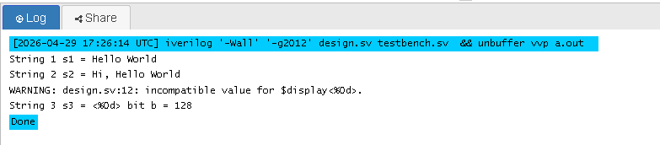
EVENT
System Verilog enhances the Verilog event in several ways. An event is now a handle to a synchronization object that can be passed around to routines. In Verilog, if the triggering thread executes before the blocking thread, the trigger is missed. System Verilog introduces triggered function that lets you check whether an event has been triggered.
event declaration examples,

event e1;
event e2;
event done;
User Defined
The user can define a new type using typedef, as in C. This can then be instantiated as,
integer_v var1;
integer_v var2;
System Verilog Enumerations
System Verilog enum data type
An enumerated type defines a set of named values. The simplest enumerated type declaration contains a list of constant names and one or more variables.
In the following example, colors are defined to be variable of the unnamed enumerated int type that includes the members red, green, blue, yellow, white, black.
enum { red, green, blue, yellow, white, black } Colors;
The actual values are defaulted to integers starting at 0 and then increase. in the above example by default variable will get the default value of 0,1,2,3,4,5 respectively from red. The values can be set for the names and also values can be set for some of the names and not set for other names. A name without a value is automatically assigned an increment of the value of the previous name.
In the following example value is set for red = 0, blue = 4, white = 10.
enum { red=0, green, blue=4, yellow, white=10, black } Colors;
green, yellow, black automatically assigned to the increment-value of 1,5,11 respectively.
If an automatically incremented value is assigned elsewhere in the same enumeration, this shall be a syntax error.
In the below example yellow will get the increment-value of 5, the value of white is set with 5. this will cause the syntax error.
enum { red=0, green=0, blue=4, yellow, white=5, black=6 } Colors
Defining new data types as enumerated types
A type name can be given so that the same type can be used in many places.
typedef enum {GOOD, BAD} pkt_type;
pkt_type pkt_a; // named type
enum methods
Method | Description
first() | returns the value of the first member of the enumeration
last() | returns the value of the last member of the enumeration
next() | returns the value of next member of the enumeration
next(N) | returns the value of next Nth member of the enumeration
prev() | returns the value of previous member of the enumeration
prev(N) | returns the value of previous Nth member of the enumeration
num() | returns the number of elements in the given enumeration
name() | returns the string representation of the given enumeration value
enum examples
Example-1 : Enumeration Type [DataTypes] This example shows how to declare enum.
CODE OF EDA PLAYGROUND:
// Code your design here
module enum_datatype;
//declaration
enum { red, green, blue, yellow, white, black } Colors;
//display members of Colors
initial begin
Colors = Colors.first;

for(int i=0;i&amp;amp;amp;amp;amp;amp;amp;amp;amp;lt;6;i++) begin
$display("Colors :: Value of %0s \t is = %0d",Colors.name,Colors);
Colors = Colors.next;
end
end
endmodule
OUTPUT:
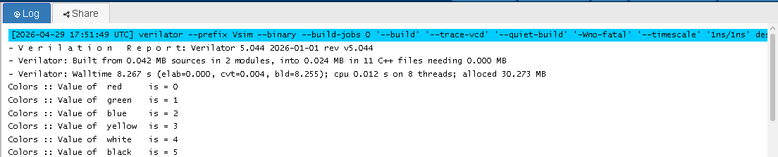
Example-2 : Enumeration Type [DataTypes]
This example shows how to set other than default values to an enum.
CODE OF EDA PLAYGROUND:
//----------------------------------------------------------------------//
// example3 : Enumeration Type [DataTypes] //
// example shows how to set values to enum other than default values //
//----------------------------------------------------------------------//
module enum_datatype;
//declaration
enum { red=0, green, blue=4, yellow, white=10, black } Colors;
//display members of Colors
initial begin
Colors = Colors.first;
for(int i=0;i<6;i++) begin
$display("Colors :: Value of %0s \t is = %0d",Colors.name,Colors);
Colors = Colors.next;
end
end
endmodule
OUTPUT:
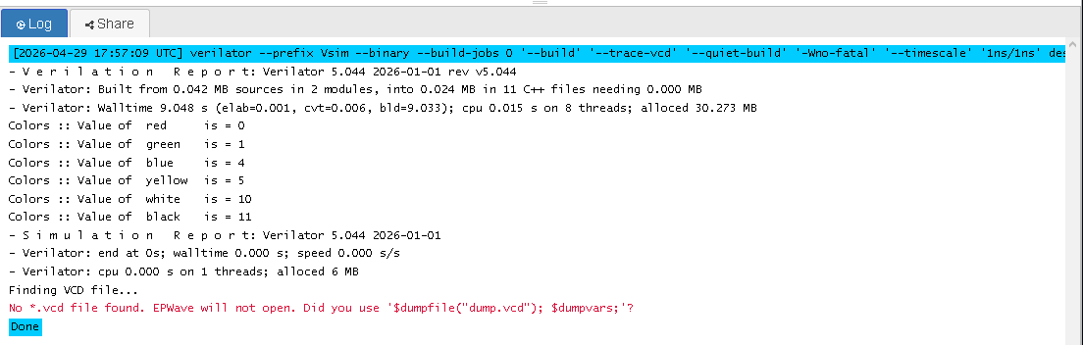
Example-3 : Enumeration Type [DataTypes]
This example shows an error, in case of automatic increment-value, is the same as the value assigned to another enum member.
CODE OF EDA PLAYGROUND:
// Code your design here
//-------------------------------------------------------------------------
// www.verificationguide.com - Enumeration Type [DataTypes]
//-------------------------------------------------------------------------
module enum_datatype;
//declaration
enum { red=0, green=1, blue=4, yellow, white=5, black=6 } Colors;

initial begin
Colors = Colors.first;
for(int i=0;i<6;i++)
$display("Colors :: Value of %0s is = %0d",Colors.name(),Colors);
end
endmodule
OUTPUT:
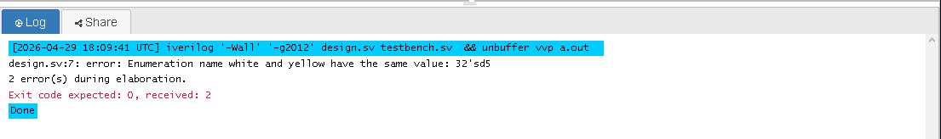
Example-4 : Enumeration Type [DataTypes]
This example shows declaring new data types using the enumerated type.
CODE OF EDA PLAYGROUND:
//-------------------------------------------------------------------------
// www.verificationguide.com - Enumeration Type [DataTypes]
//-------------------------------------------------------------------------
module enum_datatype;
//declaration
typedef enum {GOOD, BAD} pkt_type;
pkt_type pkt_a;
pkt_type pkt_b;
initial begin
pkt_a = GOOD;
pkt_b=BAD;
if(pkt_a == GOOD)
$display("pkt_a is GOOD packet");
else
$display("pkt_a is BAD packet");
if(pkt_b == GOOD)
$display("pkt_b is GOOD packet");
else
$display("pkt_b is BAD packet");
end
endmodule
OUTPUT:
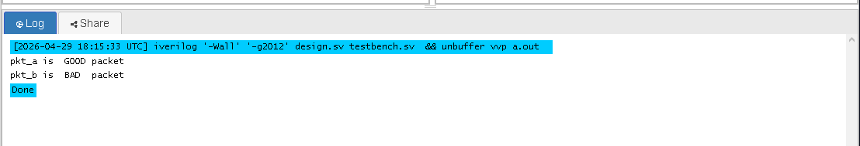
Example-5 : Enumeration Type [DataTypes]
This example shows how to use enumeration methods.
CODE OF EDA PLAYGROUND:
// Code your design here
//-------------------------------------------------------------------------
// www.verificationguide.com - Enumeration Type [DataTypes]
//-------------------------------------------------------------------------
module enum_datatype;
//declaration
typedef enum { red=0, green, blue=4, yellow, white=10, black } colors;
enum { a, b, c, d, e, f, g } alphabets;
colors first_set;
colors second_set;
initial begin
first_set = first_set.first();
$display("first_set first color is \t %0s, \t Value = %0d", first_set.name(),first_set);
first_set = first_set.last();
$display("first_set last color is \t %0s, \t Value = %0d", first_set.name(),first_set);
second_set = first_set;
$display("second_set color is \t %0s, \t Value = %0d", second_set.name(),second_set);
second_set =second_set.prev(2);
$display("second_set color is \t %0s, \t Value = %0d", second_set.name(),second_set);
second_set =second_set.next(2);
$display("second_set color is \t %0s, \t Value = %0d", second_set.name(),second_set);
$display("Number of members in alphabets is \t %0d",alphabets.num());
$display("Default First members in alphabets is \t %0s , \t value is %0d",alphabets.name(),alphabets);
alphabets=alphabets.next;
$display("Next members in alphabets is \t %0s , \t value is %0d",alphabets.name(),alphabets);
alphabets=alphabets.last;
$display("Last members in alphabets is \t %0s , \t value is %0d",alphabets.name(),alphabets);
alphabets=alphabets.prev(3);
$display("3rd members from last in alphabets is \t %0s , \t value is %0d",alphabets.name(),alphabets);
end
endmodule
OUTPUT:
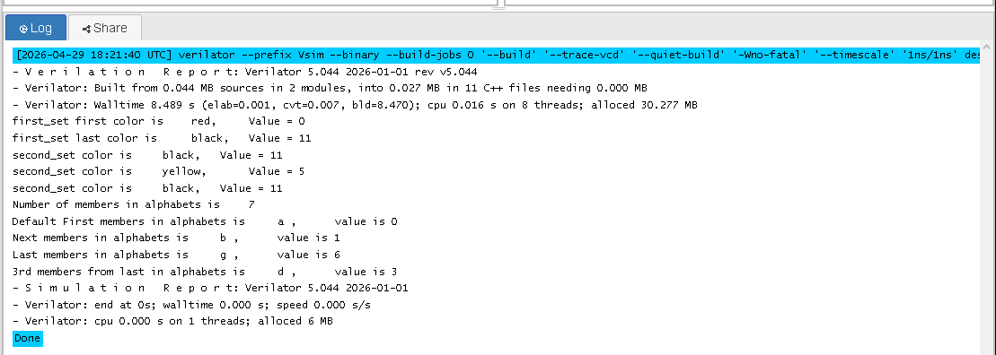
class data type
A Class is a collection of data and a set of subroutines that operate on that data. The data in a class are referred to as class properties, and its subroutines are called methods. A Class is declared using the class…endclass keywords.
Declaration Example:
class packet;
// Properties
bit [31:0] address;
bit [31:0] data ;
// Method
function new();
$display("Inside new Function of packet");
endfunction
endclass : packet
System Verilog Fixed size Array
Array in SystemVerilog
Array
An array is a collection of variables, all of the same type, and accessed using the same name plus one or more indices. there are different types of arrays, few array declaration examples are given below.
Example:
int array1 [6]; //fixed size single dimension array
int array2 [5:0]; //fixed size single dimension array
int array3 [3:0][2:0]; //fixed size multi dimension array
bit [7:0] array4[2:0]; //unpacked array declaration
bit [2:0][7:0] array5; //packed array declaration
bit [2:0][7:0] array6 [3]; //mixed packed and unpacked array
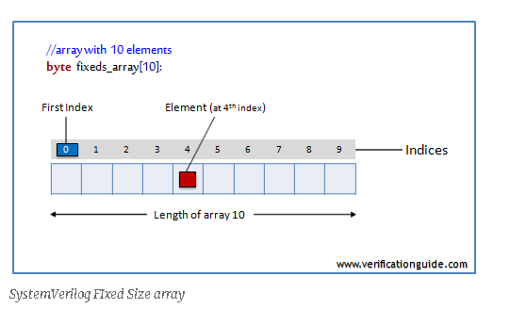
In SystemVerilog vector width/dimensions declared before the object name is referred to as packed array and array size/dimensions declared after the object name is referred to as an unpacked array.
A packed array is a mechanism for subdividing a vector into sub-fields which can be conveniently accessed as array elements.
Fixed size array
In fixed size array, array size will be constant throughout the simulation, Once the array is declared no need to create it. By default, the array will be initialized with value ‘0’.
Single dimensional array
int array1 [6]; //Compact declaration
int array2 [5:0]; // Verbose declaration
Multidimensional array
Multidimensional arrays are also known as an array of arrays.
Two-dimensional array
int arr[2][3];
This array has total 2*3 = 6 elements.
Three-dimensional array
int arr[2][2][2];
This array has total 2*2*2 = 8 elements.
Two-dimensional array declaration
int array3 [2:0][3:0];
The data in a two-dimensional array is stored in a tabular form as shown in the below diagram.
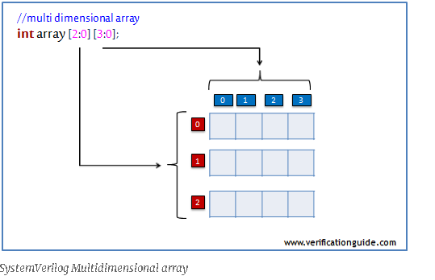
array assignment
array1 = '{0,1,2,3,4,5};
array2 = '{0,1,2,3,4,5};
array3 = '{ '{0,1,2,3},'{4,5,6,7},'{8,9,10,11}};
Fixed Size Array Example
This example shows array declaration and array manipulation using for and foreach loop.
CODE OF EDA PLAYGROUND:
// Code your design here
//-------------------------------------------------------------------------
// www.verificationguide.com
// Fixed Size array
//-------------------------------------------------------------------------
module fixedsize_array;
//declaration of array’s
int array1[6]; //single dimension array
int array2[5:0]; //single dimension array
int array3[2:0][3:0]; //multi dimension array
int array4[4:0];
initial begin
//array initialization
array1 = '{0,1,2,3,4,5};
array2 = '{0,1,2,3,4,5};
array3 = '{'{0,1,2,3},'{4,5,6,7},'{8,9,10,11}};
//displaying array elements
$display("-------displaying array1-------");
foreach(array1[i]) $display("\t array1[%0d] = %0d",i,array1[i]);
$display("-------displaying array2-------");
for(int i=0;i<6;i++) $display("\t array2[%0d] = %0d",i,array2[i]);
$display("-------displaying array3-------");
foreach(array3[i,j]) $display("\t array3[%0d][%0d] = %0d",i,j,array3[i][j]);
$display("-------displaying uninitialized array4-------");
for(int i=0;i<5;i++) $display("\t array4[%0d] = %0d",i,array4[i]);
end
endmodule
OUTPUT:
[2026-04-29 18:33:34 UTC] verilator --prefix Vsim --binary --build-jobs 0 '--build' '--trace-vcd' '--quiet-build' '-Wno-fatal' '--timescale' '1ns/1ns' design.sv testbench.sv && obj_dir/Vsim
- V e r i l a t i o n R e p o r t: Verilator 5.044 2026-01-01 rev v5.044
- Verilator: Built from 0.043 MB sources in 2 modules, into 0.035 MB in 9 C++ files needing 0.000 MB
- Verilator: Walltime 8.494 s (elab=0.001, cvt=0.011, bld=8.470); cpu 0.019 s on 8 threads; alloced 30.273 MB
-------displaying array1-------
array1[0] = 0
array1[1] = 1
array1[2] = 2
array1[3] = 3
array1[4] = 4
array1[5] = 5
-------displaying array2-------
array2[0] = 5
array2[1] = 4
array2[2] = 3
array2[3] = 2
array2[4] = 1
array2[5] = 0
-------displaying array3-------
array3[2][3] = 0
array3[2][2] = 1
array3[2][1] = 2
array3[2][0] = 3
array3[1][3] = 4
array3[1][2] = 5
array3[1][1] = 6
array3[1][0] = 7
array3[0][3] = 8
array3[0][2] = 9
array3[0][1] = 10
array3[0][0] = 11
-------displaying uninitialized array4-------
array4[0] = 0
array4[1] = 0
array4[2] = 0
array4[3] = 0
array4[4] = 0
- S i m u l a t i o n R e p o r t: Verilator 5.044 2026-01-01
- Verilator: end at 0s; walltime 0.000 s; speed 0.000 s/s
- Verilator: cpu 0.000 s on 1 threads; alloced 6 MB
Done

